LAB 7 Microsoft access
Exercise

- Create a database called Library. This database will store information about publishers, authors, types of books and books.
- Create the following tables. Before you create the tables, look at the definitions below. Identity the primary keys (the fields written in bold). Identify the foreign keys. Identify the type of relationship (is it one-to-one, one-to-many). When creating the foreign keys, use the lookup wizard to look up the value on the parent table.

Note: The fields written in bold are primary keys.

Table Name: Publishers
Field Name | Data Type | Field Size
PublisherCode | Text | 14
PublisherName | Text | 30
PublisherAddress1 | Text | 30
PublisherAddress2 | Text | 30
PublisherAddress3 | Text | 30

Table Name: Authors
Field Name | Data Type | Field Size
AuthorCode | Text | 14
AuthorName | Text | 30
AuthorAddress1 | Text | 30
AuthorAddress2 | Text | 30
AuthorAddress3 | Text | 30

Table Name: BookTypes
Field Name | Data Type | Field Size
BookType | Text | 14
Description | Text | 30

Table Name: Books
Field Name | Data Type | Field Size
BookNo | AutoNumber
BookTitle | Text | 30
AuthorCode | Text | 14
PublisherCode | Text | 14
DateOfPublication | Date/Time
BookType | Text | 14

- Open the relationships window and you will see that the relationships have already been created. Select each relationship and edit it (Click on relationship to select. Right-mouse click and choose edit relationship from shortcut menu). Enforce Referential Integrity.

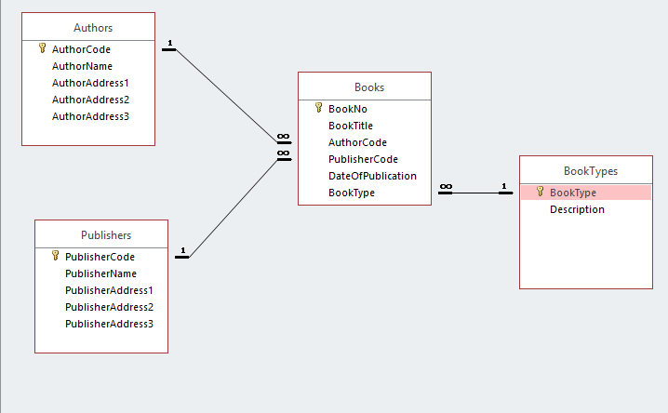

- Using the form Wizard, create forms for the above tables.
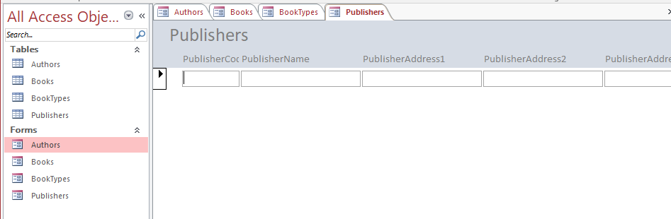

- Using the forms, enter the following information.

Table: Publishers
PublisherCode | PublisherName | PublisherAddress1 | PublisherAddress2 | PublisherAddress3
JW01 | John Wiley & Sons Ltd | Bognor Regis | West Sussex | UK
HC01 | Harper Collins | Main Street | Ennis | Co Clare
PH01 | Prentice Hall | Trafalgar Square | London | UK
ID01 | IDG Books Worldwide | 155 Bovet Road | San Mateo | CA

Table: Authors
AuthorCode | AuthorName | AuthorAddress1 | AuthorAddress2 | AuthorAddress3
CP01 | Cary N Prague | Main St | Kilfeacle | Co Clare
MI01 | Michael R Irwin | New St | Killarney | Co Kerry
LG01 | Leonard Gribble | 178 Great Portland St | London W1 | England
MP01 | Maurice Punch | 97 Henry St | Limerick City | Limerick

Table: Book Types
BookType | Description
F01 | Fiction – Preschool
F02 | Fiction – 4 Year Old
F12 | Fiction – Science Fiction
SC01 | Science – Overview
SC02 | Science – Chemistry
SC12 | Science – Computer Science

Table: Books
Book Title | AuthorCode | PublisherCode | DateOfPublication | BookType
Jeremy & the Gifaffe | LG01 | ID01 | 01/06/07 | F01
Data Structures | MI01 | HC01 | 01/09/05 | SC12
A Trip to Mars | CP01 | PH01 | 01/08/07 | F12
Science explained | CP01 | HC01 | 21/05/06 | SC01
Algorithms | MP01 | PH01 | 12/04/05 | SC12

Note: No information was given for the BookNo. This is automatically allocated its value by access.

- Create a query to show all details of the book publishers from the UK. Save as query as qryUKPublishers.

SELECT Publishers.PublisherCode, Publishers.PublisherName, Publishers.PublisherAddress1, Publishers.PublisherAddress2, Publishers.PublisherAddress3
FROM Publishers
WHERE (((Publishers.PublisherAddress3)="UK"));

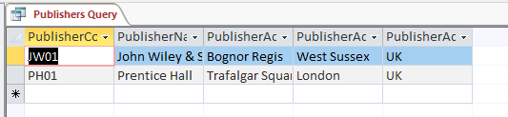

- Create a query to show the Book Title, Publication Date of all books published in 2007. save as qryPub2007. Create a form based on this query. Save as FrmPub2007.

SELECT Books.[BookTitle], Books.[DateOfPublication]
FROM Books
WHERE (([DateOfPublication]>=#1/1/2007# And [DateOfPublication]<=#12/31/2007#));

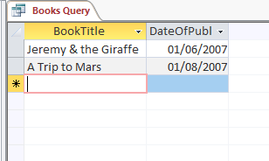
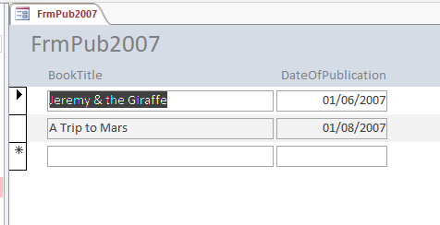

- Create a query to show all details of all books published between 2004 and 2006. Save as qryDates.
SELECT Books.BookNo, Books.BookTitle, Books.AuthorCode, Books.PublisherCode, Books.DateOfPublication, Books.BookType
FROM Books
WHERE (([DateOfPublication]<=#12/31/2006# And [DateOfPublication]>=#1/1/2004#));

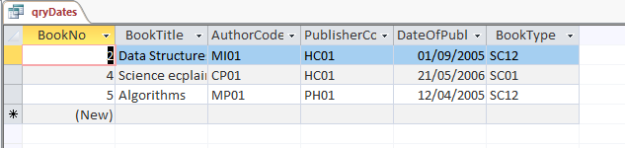

- Open the Authors table in Design View.
- Add a new field called Gender. Data Type = Text. Field Size = 1
- Validations rule for this field is “M” or “F”.
- Ensure that data is entered using capital letters at all times (Format Property >)
- Validation Text is Valid values for Gender are M(ale) and F(emale). Save the table
- Go to Datasheet View, for existing authors, enter the correct gender.
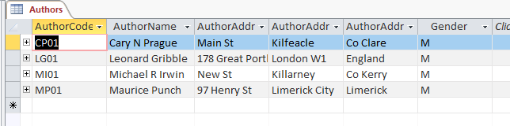

- Using the Form Wizard create a form to display the books written by each Author. Save as FrmAuthorBooks.

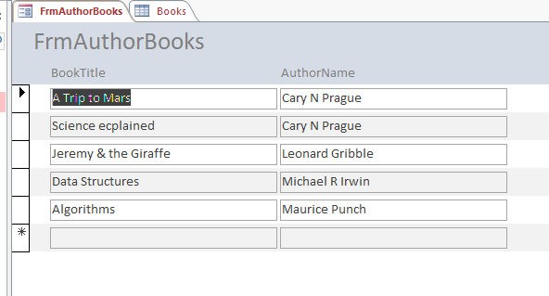

- Create a query to display the books written by each author. Show the Author Name and Book Title. Save as qryAuthor&Book
SELECT Books.BookTitle, Authors.AuthorName
FROM Authors INNER JOIN Books ON Authors.[AuthorCode] = Books.[AuthorCode];

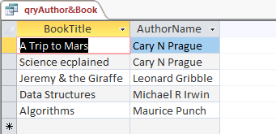
- Create a query to display all the books of type Science published by Harper Collins. Save as qryHCScienceBooks.

SELECT Publishers.PublisherName, Books.BookTitle, Books.BookType, BookTypes.Description
FROM Publishers INNER JOIN (BookTypes INNER JOIN Books ON BookTypes.[BookType] = Books.[BookType]) ON Publishers.[PublisherCode] = Books.[PublisherCode]
WHERE (((Publishers.PublisherName)="Harper Collins") AND ((BookTypes.Description) Like "Science*"));
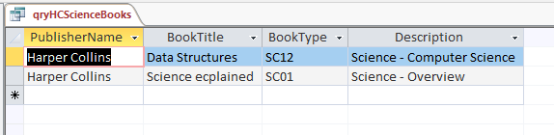

- Add a new field called BookPrice of type currency to Table Books. Assign the books the following Prices
BookNo | Book Title | AuthorCode | PublisherCode | DateOfPublication | BookType | BookPrice
1 | Jeremy & the Gifaffe | LG01 | I001 | 01/06/07 | F01 | €14.95
2 | Data Structures | MI01 | HC01 | 01/09/05 | SC12 | €65.95

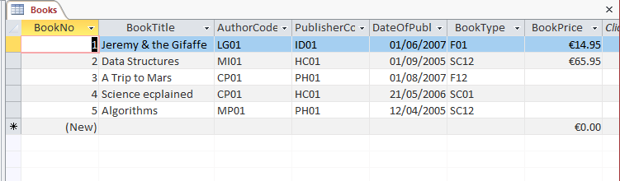

- Create a query called QryBookSalePrices. There is a sale giving a 5% reduction on the BookPrice of all books in the Fiction – Preschool (F01) Book Type category. In the query create new field called SalesPrice. Use an If statement to calculate the SalePrice (i.e. 5% off BookPrice i.e. [BookPrice]*0.95).

SELECT Books.[BookNo], Books.[BookTitle], Books.[AuthorCode], Books.[PublisherCode], Books.[DateOfPublication], Books.[BookType], Books.[BookPrice], IIf([BookType]="F01",[BookPrice]*0.95,[BookPrice]) AS SalesPrice
FROM Books;
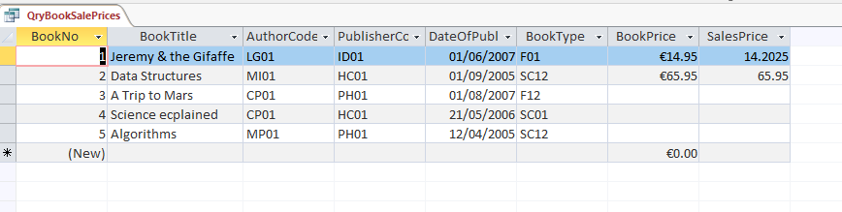
- Using Report Wizard, create a report based on QryBookSalePrices which lists the sale prices for each book. Save as RptBookSalePrices.

